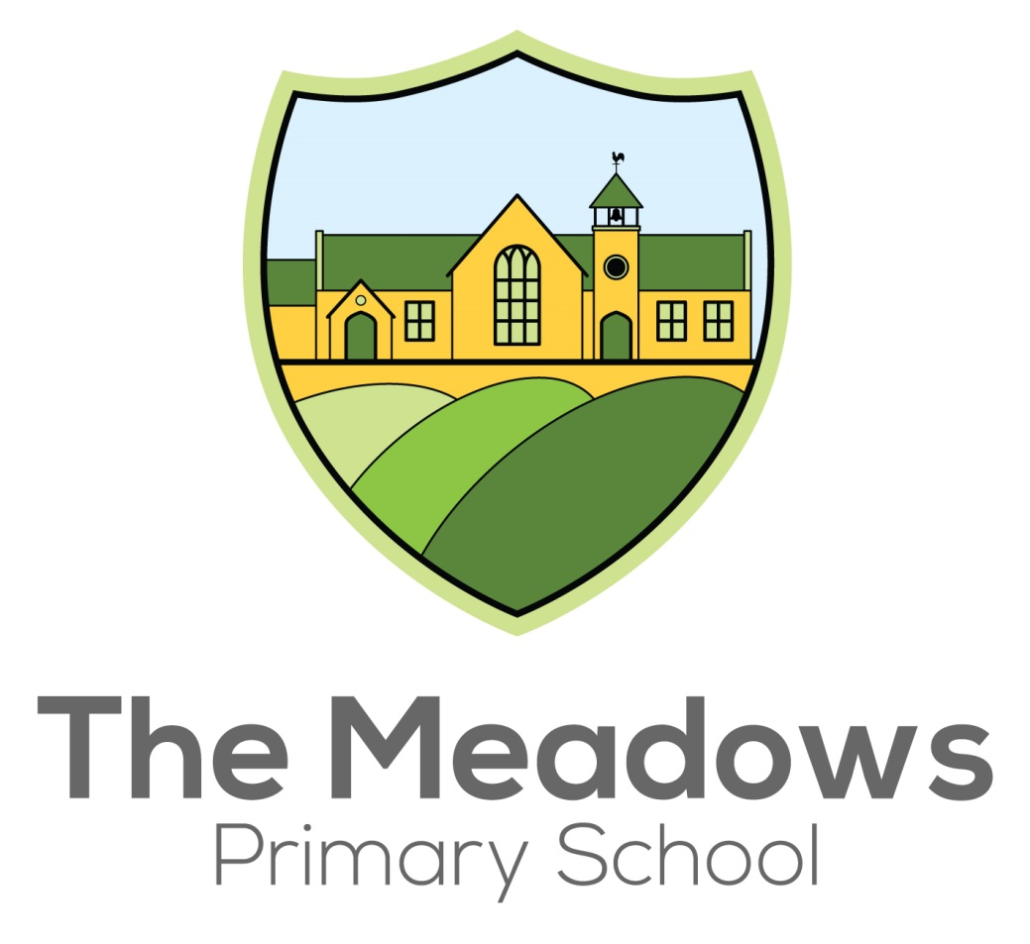
Nursery Admissions Policy

Following consultation with the Shaw Education Trust Executive Team The Meadows Primary School is now responsible for the Nursery Admissions process. Admission to our Nursery is subject to an application being made and places subject to availability.
Nursery Places
There are currently 16 Nursery places available between 9am & 3.00pm. Children will be eligible to attend the Nursery immediately after their 3rd birthday
We run morning and afternoon sessions, 3 hours per session Monday to Friday from 9am to 12 noon & 12pm – 3.00pm. Additional wraparound care outside standard nursery times are available through our wraparound team.
All of our sessions are chargeable (unless you receive Universal 15 or Extended 30 hours funding).
Costs of Provision
Before School Club  From 7:30am | £4.50 per day  £22.50 per week | Breakfast provided
After School Club  Until 6:00pm | £8.50 per day  £42.50 per week | Snack provided
9:00am – 12:00pm  or  12:30pm – 3:30pm | £15.00 per day  £65.00 per week | Fruit/toast and milk provided
Full Day  7:30am – 6:00pm | £37.50 per day  £175.00 per week | Hot lunch available at an extra cost. Alternatively, please send a packed lunch.
Morning  7:30am – 12:00pm | £19.00 per day  £85.00 per week | Fruit/toast and milk provided
afternoon  12:30pm – 6:00pm | £22.50 per day  £105 per week | Snack included

Please note that the late collection of a child will incur additional charges.
Funded Childcare

All funded hours can be used term time only. Parents receiving 15 free hours childcare can use these hours in our morning sessions only. Where applicants receive Universal 15 or Extended 30 hours funding an EEF funding form will need to accompany the application form. This is to support staffing the Nursery and to ensure children to not miss out on key learning.

How to apply

Information about the provision we offer, and our open days can be found on our website. Applications open, close and offer dates are outlined below. We reserve the right to amend our application process at any point including the dates and number of intakes.

An application form is available in the Nursery admissions section of our website.

Completed application forms should be sent to:
office@meadowsprimary.shaw-education.org.uk.

Application for September Intake
As we are a new provision, we are flexible with the admissions process this year. Applications are now open. Round One will close 9th July. Subject to our maximum capacity not being exceed, places will be guaranteed for September.
Round Two will close on 31st August. Available places will be subject to the staffing ratios already in place.

Applications Throughout the Year
- Spring Term – January Intake: Applications open from Monday 3rd September to Friday 22nd October 2021
- Summer Term – April Intake: Applications open from Monday 3rd January to Friday 4th February 2022
- Autumn Term – September Intake: Applications open from Tuesday 1st March to Friday 29th April 2022

Oversubscription Criteria

It is our policy to try and meet parents’ wishes where possible, however, in some cases there may be more applications for a Nursery intake than there are places and in this instance admission to Nursery will be determined by the oversubscription criteria detailed below.

In accordance with legislation, children who have an Education, Health and Care Plan that names our nursery must be admitted. This will reduce the number of places available to other applicants.
Thereafter places will be offered in accordance with the following specified criteria:
- Relevant Children in Care, including those previously determined as Looked After Children. (That is, children who were looked after but ceased to be so because they were adopted or became subject to a residence order or special guardianship order).

- Children who have an elder brother or sister in attendance at the school and who will still be attending the school at the time of the proposed admission date. (For admission purposes, a brother or sister is a child who lives at the main address provided and either: have one or both natural parents in common; are related by a parents marriage; are adopted or fostered by a common parent or are unrelated children who live at the main address, whose parents live as partners.)

- Children will be offered a place in consideration of the number of sessions requested. (We strictly adhere to child to adult ratios and child to floor space ratios as set out by Ofsted)

- Children who will be eligible to apply for a Reception place based on distance from school.
Distance is measured using the Google Walking Map for Nursery applications only and is in no way linked with the Reception Admissions method of calculation via the Local Education Authority’s Admission Team.
Waiting List
Where The Meadows Nursery is oversubscribed, a waiting list will be maintained in criteria order where ranking places for applicants may change dependent on further applications being submitted.
Please note Nursery education is a non-statutory provision and there is therefore no right of appeal against the admission authority’s decision.
The Meadows expects that parents applying for places for their children will accept and uphold the attendance policy for our school, where the expectation is pupils attend every day. If a nursery child misses 10 days during a half term without any viable explanation, a meeting will be called with the headteacher and this could lead to the nursery place being revoked.
Admission to the school’s Nursery does not guarantee admission to the Reception class at our school. Applications for Reception must be made on a separate application through the Local Authority and be submitted by the statutory deadline in order to be considered.

