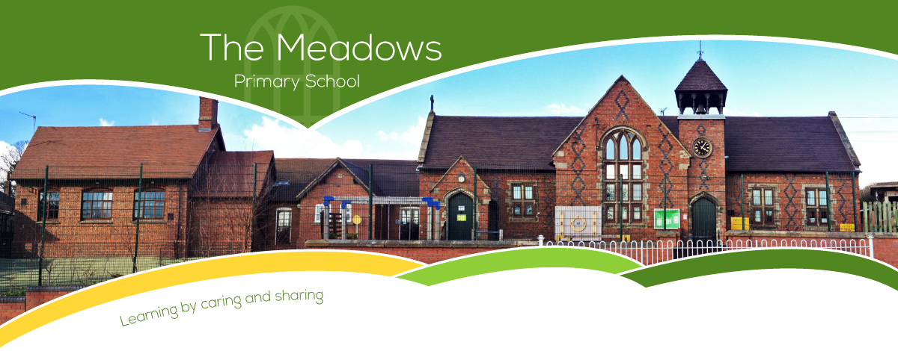

Class 3 – Odd Year Planning (September 2021-July 2022)
Subject | Autumn Term |  | Spring Term |  | Summer Term
Literacy  SMSC link: All | - How To Train Your Dragon  - How far would I go to look cool?  - Sounds Spooky  - Exploring poetic language  - Brilliant Books (John Lewis) |  | - The Spiderwick Chronicles  - The Most Incredible Sport  - Creating images |  | - Christophe’s Story  - Chat Show Challenge  - The Grand Tour  - Shape poetry
Maths  SMSC link: Social | - Number and place value  - + - ÷ x methods  - Properties of shape  - Position and direction | - Fractions  - Decimals  - Mass  - Time | - Number and place value  - + - ÷ x methods  - Properties of shape  - Fractions  - Length | - Decimals  - Perimeter | - Number and place value  - + - ÷ x methods  - Properties of shape  - Money | - Volume and capacity  - Position and direction  - Fractions  - Area
Science  SMSC link:  Cultural  Social  Moral | - States of matter: In a State (Chem)  - Sound: Good vibrations (Phy) |  | - Our Changing World  - Light: Can you see me? (Phy) |  | - How does your Garden Grow?
Computing  SMSC link:  Cultural  Social  Moral | - Digital Literacy( (Year 3 Unit)  - Online Safety (Year 3 Unit)  - Programming Scratch (Year 3 Unit) |  | - Investigating Weather (Year 4 Unit)  - Networks and the Internet (Year 4 Unit) |  | - HTML (Year 4 Unit)  - Website Design (Year 4 Unit)
History  SMSC link: All | - Land Ahoy! (The Vikings and the Anglo Saxons) |  | - A local history study (Staffordshire Hoard) |  | - A local history (Mining)

Geography  SMSC link: All | - Somewhere to Settle  - International Trade; Natural resources and food | - International Trade: Tourism  - Transportation | - Earthquakes, Mountains and Volcanos
Art/DT  SMSC link: Social  Cultural | - Formal Elements (Year 4 Unit)  - Constructing Castles (Year 3 Unit) | - Every Picture Tells a Story (Year 4 Unit)  - Eating Seasonally (Year 3 Unit) | - Art and Design Skills (Year 3 Unit)  - Slingshot Car (Year 4 Unit)
Music  SMSC link: Social  Cultural | - Ukulele | - Ukulele | - Ukulele
PSHE | - One World  - Safety First | - Think Positive  - It's My Body | - Respecting Rights
PE  SMSC link: Social | - Swimming  - Hockey  - Netball  - Gymnastics | - Cricket  - Tag rugby  - Gymnastics/Dance | - Athletics  - Dance
RE | - How can Brahman be everywhere and in everything? (Hinduism)  - What is the most significant part of the nativity story for Christians today? (Christianity) | Is forgiveness always possible? (Christianity)  What is the best way for a Sikh to show commitment to God? (Sikhism) | - Would visiting the River Ganges feel special to a non Hindu? (Hinduism)  - What is the best way for a Sikh to show commitment to God? (Sikhism)
French  SMSC link: Social  Cultural | - Phonetics (Phonics) – 2021 to help with catch up.  - En famille (my family)  - Je Me Présente (Presenting Myself) | - Chez moi (my home)  - Les Instruments (Musical Instruments) | - Au café (café)  - Quelle est la date aujourd hui? (What is the date?)

