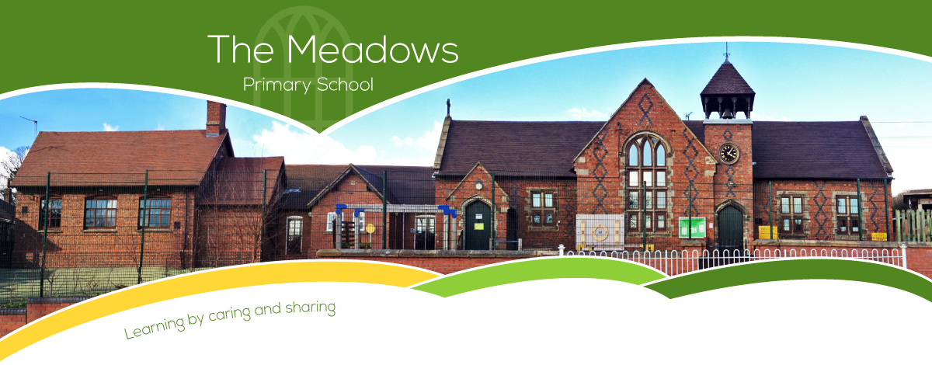

Class 3 – Even Year Planning (September 2022-July 2023)
Subject | Autumn Term |  | Spring Term |  | Summer Term
Literacy | - Brilliant Books – John Lewis Advert  - Storm  - Was Tutan killed?  - Performance Poetry |  | - Iron Man  - Exploring poetic form  - The Grand Tour |  | - Ottoline and the Yellow Cat  - Wanted: Space Explorer  - Playing with words
Maths | - Number and place value  - + - ÷ x methods  - Properties of shape  - Position and direction | - Fractions  - Decimals  - Mass  - Time | - Number and place value  - + - ÷ x methods  - Properties of shape  - Fractions  - Length | - Decimals  - Statistics  - Percentages (FDP)  - Perimeter and area | - Number and place value  - + - ÷ x methods  - Properties of shape  - Money | - Volume and capacity  - Position and direction  - Fractions  - Area
Science | - Amazing Bodies  - Where does all the Food Go? |  | - Our Changing World  - Switched On |  | - The Power of the Force  - Can You See Me?  - Theme week: Space
Computing | - Online Safety (Year 4 Unit)  - Emailing (Year 3 Unit) |  | - Top Trumps: Databases (Year 3 Unit)  - Further coding with Scratch (Year 4 Unit) |  | - Computational Thinking (Year 4 Unit)  - Collaborative Learning (Year 4 Unit)
History | - Rock of Ages (The Stone Age to the Iron Age) |  | - Radical Romans |  | - Smashing Saxons and Scots
Geography | - Maps of the World  - Transportation |  | - Rivers |  | - Europe
Art/DT | - Prehistoric Art (Year 3 Unit)  - Food: Adapting a Recipe (Year 4 Unit) |  | - Craft (Year 3 Unit)  - Electronic Charms (Year 3 Unit) |  | - Sculpture (Year 4 Unit)  - Cushions (Year 3 Unit)
Music | - Ukulele |  | - Ukulele |  | - Ukulele
PSHE | - TEAM  - Be Yourself |  | - Aiming High  - Growing Up |  | - VIPs  - Britain

PE | - Swimming  - Hockey  - Netball  - Gymnastics | - Cricket  - Tag rugby  - Gymnastics/Dance | - Athletics  - Dance
RE | - Would celebrating Divali at home and in the community bring a feeling of belonging to a Hindu child? (Hinduism)  - Has Christmas lost its true meaning? (Christianity) | - What is ‘good’ about Good Friday? (Christianity)  - Does joining the Khalsa make a person a better Sikh? (Sikhism) | - Do people need to go to church to show they are Christians? (Christianity)  - Could Jesus really heal people? Were these miracles or is there some other explanation? (Christianity)
French | - Phonetics (Phonics) Not it 2022 as used in 2021 to catch up.  - J'Apprends Le Français (I'm Learning French)  - L’ancienne Histoire de la Grande Bretagne (Ancient Britain) Y3 | - De la Classe (in class)  - Les Fruits (The Fruits)  - Les Légumes (The Vegetables) | - Je Me Presente (Presenting Myself)  - Les habitats (Habitats)

