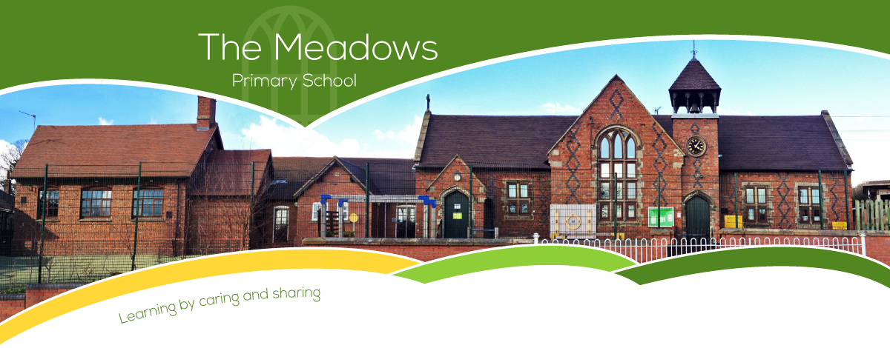

Class 4 – Odd Year Planning
Subject | Autumn Term |  | Spring Term |  | Summer Term
Literacy | - Fiction: Narrative – Cosmic  - Fiction: Narrative Horror - A Monster Calls  - Poetry - Malfaesance  - Non-fiction - Persuasive Letter – Scrooge |  | - Non-fiction - Journal - Mars Transmission  - Fiction: Narrative - The Explorer  - Fiction: Narrative – One Small Step |  | - Non-Fiction – Speech: Greta  - Fiction: Narrative - Adventure in Dystopian World – Tyger  - Poetry - Narrative Poem - Hope-o-potamus  - Non-Fiction – Biography: David Attenborough
Maths | - Number and place value  - + - ÷ x methods  - Properties of shape  - Position and direction | - Fractions  - Decimals  - Mass  - Time | - Number and place value  - + - ÷ x methods  - Properties of shape  - Fractions  - Length | - Decimals  - Statistics  - Percentages (FDP)  - Perimeter and area | - Number and place value  - + - ÷ x methods  - Properties of shape  - Money  - Fractions | - Volume and capacity  - Percentages (FDP)  - Position and direction  - Statistics
Science | - Feel the Force  - The Earth and Beyond |  | - Material Properties |  | - Reproduction in Plants and Animals
Computing | - Y6 - Online safety  - Computing systems and networks: Search engines |  | - Data handling: Mars rover (1)  - Programming: Music |  | - Creating Media: Stop motion animation  - Programming 2: Micro:bit
History | - The round city: Baghdad  - The Anglo-Saxons |  | - Vikings 1 – Lady of the Mercians  - Norse Culture |  | - Vikings 2 – Changing rulers, changing worlds  - Local history study
Geography | - Why is California so thirsty?  - Oceans |  | - Migration  - North and South America |  | - The Amazon  - Interconnected Amazon
Art/DT | - Bridges  - I need space |  | - Stuffed Toys  - Portraits |  | - Monitoring Devices  - Photo opportunity
Music | - Composition notation (Theme: Ancient Egypt)  - Film music |  | - South America (Instrumental lessons)  - North America (Instrumental lessons) |  | - Theme and variations (Theme: Pop Art)  - Composing and performing a Leavers' song
PE | - Hockey  - Netball  - Gymnastics |  | - Cricket  - Tag rugby  - Gymnastics/Dance |  | - Outdoor adventure  - Athletics  - Dance
PSHE | - Be Yourself  - Britain |  | - Aiming High  - It's My Body |  | - TEAM  - Moving to high school
RE | - Islam 2: Stories of the prophets  - Islam 3: Living Muslim traditions |  | - Christianity 6: Living Christian Traditions  - Buddhism: the prince who became the Buddha |  | - Awaiting Opening World Resources
Spanish | - Phonics 3&4 (C)  - The Date (I)  - My Home (I) |  | - Clothes (I)  - Planets (P) |  | - Healthy Living (P)  - Me in the World (P)

