Class 4 Spring – Odd Year

Subject | Learning Hook | Context | Prior Learning
History | Investigate and interpret the past  Build an overview of world history  Understand chronology  Communicate historically | 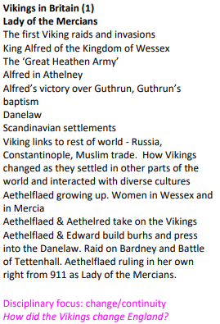  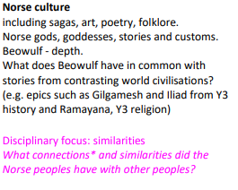 | Understanding of chronology – Ancient Egypt, The Victorians, WW2, The Romans, The Vikings, The Stone age
Science | Investigate Materials  Investigate Light and Seeing  Work scientifically | The Earth and Beyond  Light Up Your World | Can you see me (Y3/4)  Senses (KS1)
Geography | Investigate patterns  Communicate geographically  Investigate places | 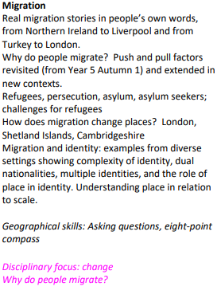  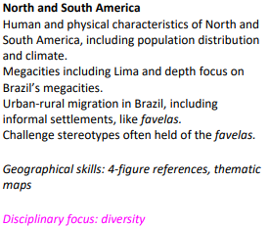 | Settlements (Stone Age, Romans and Anglo-Saxons)  Local area study  Map Skills  The Americas (Y5/6)  Around the World (Y3/4)
Design and Technology | Master practical skills  Design, make, evaluate and improve  Take inspiration from design throughout history | Stuffed Toys  - Outline a portrait drawing with words, varying the size, shape and placement of words to create interest.  - Try a variety of materials and compositions for the backgrounds of their drawings.  - Communicate to their partner what kind of photo portrait they want.  - Show that they are making decisions about the position of a drawing on their background, trying multiple ideas.  - Create a successful print.  - Use some Art vocabulary to talk about and compare portraits.  - Identify key facts using a website as a reference.  - Explain their opinion of an artwork.  - Experiment with materials and techniques when adapting their photo portraits.  - Create a self-portrait that aims to represent something about them.  - Show they have considered the effect created by their choice of materials and composition in their final piece. | Master practical skills (Y1,2,3,4, 5)  Design, make, evaluate and improve (Y1,2,3,4, 5)  Take inspiration from design throughout history (Y1,2,3,4, 5)
Art and Design | Develop ideas  Master techniques  Take inspiration from the greats | Portraits  - Outline a portrait drawing with words, varying the size, shape and placement of words to create interest.  - Try a variety of materials and compositions for the backgrounds of their drawings.  - Communicate to their partner what kind of photo portrait they want.  - Show that they are making decisions about the position of a drawing on their background, trying multiple ideas.  - Create a successful print.  - Use some Art vocabulary to talk about and compare portraits.  - Identify key facts using a website as a reference.  - Explain their opinion of an artwork.  - Experiment with materials and techniques when adapting their photo portraits.  - Create a self-portrait that aims to represent something about them.  - Show they have considered the effect created by their choice of materials and composition in their final piece. | Describe the work of notable artists,  artisans and designers (EYFS, Y1, Y2, Y3, Y4, Y5)
Religious Education | Understand beliefs and teachings  Understand practices and lifestyles  Understand how beliefs are conveyed  Reflect  Understand values | - Awaiting Opening World Resources | Understand beliefs and teachings (Y1,2,3,4, 5)  Understand practices and lifestyles (Y1,2,3,4, 5)  Understand how beliefs are conveyed (Y1,2,3,4, 5)  Reflect (Y1,2,3,4, 5)  Understand values(Y1,2,3,4, 5)
Languages | Read fluently  Write imaginatively  Speak confidently | Clothes (I)  Spanish phonemes/ alphabet GA GE GI GO GU QU Z,  Repeat and recognise the vocabulary for a variety of clothes in Spanish. Use the appropriate genders and articles for these clothes. Use the verb LLEVAR in Spanish with increasing confidence. Say what they wear in different weather/situations. Describe clothes in terms of their colour and apply adjectival agreement. Use the possessives with increased accuracy.  Planets (P)  Spanish phonemes: alphabet CH, J, Ñ, LL, RR  CA, CE, CI, CO, CU, B V CC GA GE GI GO GU QU Z,  B, V, CC  Name and spell accurately some/all the planets in Spanish on a solar map. Say and write extended sentences for at least one planet. • Understand better the rules of adjectival agreement in Spanish and apply these rules to my work improving grammatical accuracy. | Spanish Phonics (Y3/4/5)  Presenting myself (Y3/4/5)
Physical Education | Develop practical skills in order to participate, compete and lead a healthy lifestyle | Cricket  Tag rugby  Gymnastics/Dance | Gymnastics (Y3/4)  Net and Wall (Y3/4)  Invasion Games (Y3/4)
Computing | Code  Collect  Communicate  Connect | Data handling: Mars rover (1)  - Identify some of the types of data that the Mars Rover could collect (for example, photos).  - Explain how the Mars Rover transmits the data back to Earth and the challenges involved in this.  - Read any number in binary, up to eight bits.  - Identify input, processing and output on the Mars Rovers.  - Read binary numbers and grasp the concept of binary addition.  - Relate binary signals (Boolean) to a simple character-based language, ASCII.  Programming: Music  - Iterate ideas, testing and changing throughout the lesson. Explain what the basic commands do.  - Explain how their program links to the theme. Include a loop in their work. Correct their own simple mistakes.  - Explain their scene in the story. Link musical concepts to their scene. Include a repeat and explain its function to enhance music.  - Code a piece of music that combines a variety of structures. Use loops in their programming.  - Recognise that programming music is a way to apply their skills | Code (Y1,2,3,4, 5)  Collect (Y1,2,3,4, 5)  Communicate (Y1,2,3,4, 5)  Connect (Y1,2,3,4, 5)
Maths | Use measures  Use algebra  Use fractions | - Decimals  - Percentages  - Algebra  - Perimeter  - Ratio and Proportion | Know and Use Numbers (Y3/4/5)  Add and subtract (Y3/4/5)  Multiply and divide (Y3/4/5)  Use fractions (Y3/4/5)
English | Understand texts  Transcribe  Compose  Analyse  Present | - Non-fiction - Journal - Mars Transmission  - Fiction: Narrative - The Explorer  - Fiction: Narrative – One Small Step | Understand texts (Y1,2,3,4)  Transcribe (Y1,2,3,4)  Compose (Y1,2,3,4)  Analyse (Y1,2,3,4)  Present (Y1,2,3,4)
PSHE | Changing Bodies  Mental wellbeing | Aiming High  In this unit of work, children will focus on achievements,  aspirations and opportunities. They will start by discussing  achievements they have accomplished so far and the type of  attitude that helps us succeed. They will also learn about their  own personal preferred learning styles, to understand how they  learn best. Children will look at challenges people face and  barriers to success, then think about strategies we can use to  overcome such obstacles. They will identify opportunities that  are available to them now and those which may be available  to them in the future. Stereotypes in the world of work will be  addressed, as children are encouraged to consider jobs they  would like to do and the skills needed to do those jobs. The  children will also have the opportunity to reflect on their personal  goals and the steps they can take to achieve these in the future.  It's My Body  In this unit of work, children will learn about how to take  care of their bodies. This will involve learning about  consent and autonomy, learning about body image and  stereotypes and learning about substances which are  harmful to our bodies. Children will also learn about  the importance of sleep, exercise and hygiene. Lessons  will explore the things that influence the way people  think about their bodies, where different pressures can  come from and how these pressures can be resisted.  Throughout the unit, children will be encouraged to  consider the choices they have, healthy habits that can  benefit us all and how to seek support should they need  to. | Changing bodies (Y1,2,3,4,5)  Mental wellbeing (Y1,2,3,4,5)
Music | Perform  Compose  Transcribe  Describe music | South America (Instrumental lessons)  Learning about the history and features of Latin America music, performing a salsa style song and playing from staff notation; performing a mini carnival using a range of performance techniques including song, dance, tuned and untuned musical instruments.  North America (Instrumental lessons)  Exploring minimalism and the music of composers like Philip Glass and Steve Reich, children learn to identify music features such as interlocking patterns and layered textures. They learn to sing and play the piece ‘Interlocking patterns’ as they apply their skills reading staff notation and playing tuned percussion. | Geography links (see above)  Perform (Y1,2,3,4,5)  Compose (Y1,2,3,4,5)  Transcribe (Y1,2,3,4,5)  Describe music (Y1,2,3,4,5)

