Class 4 Autumn – Odd Year

Subject | Learning Hook | Context | Prior Learning
History | Investigate and interpret the past  Build an overview of world history  Understand chronology  Communicate historically | The round city: Baghdad  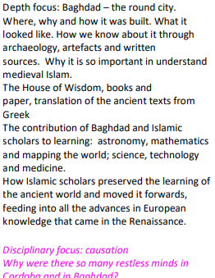  The Anglo-Saxons  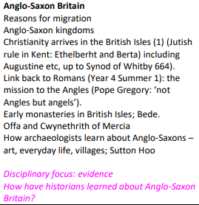 | Understanding of chronology – Ancient Egypt, The Victorians, WW2, The Romans, The Vikings, The Stone age
Science | Investigate Materials  Investigate Light and Seeing  Work scientifically | Physics - Understanding movement, forces and magnets: Feel the force Magnets • Describe magnets as having two poles.  • Predict whether two magnets will attract or repel each other, depending on which poles are facing.  Forces  • Explain that unsupported objects fall towards the Earth because of the force of gravity acting between the Earth and the falling object. • Identify the effect of drag forces, such as air resistance, water resistance and friction that act between moving surfaces.  • Understand that some mechanisms including levers, pulleys and gears, allow a smaller force to have a greater effect. Comparative and fair testing Pattern seeking Identify and classify Research (Isaac Newton, Aristotle)  Physics - Describe the Earth’s movement in space:  The Earth and beyond  • Describe the movement of the Earth, and other planets, relative to the Sun in the solar system.  • Describe the movement of the Moon relative to the Earth  • Describe the Sun, Earth and Moon as approximately spherical bodies. • Use the idea of the Earth’s rotation to explain day and night and the apparent movement of the sun across the sky. Observation Research Comparative test Galileo Galilei Katherine Johnson Mae Jemison | Can you see me (Y3/4)  Senses (KS1)
Geography | Investigate patterns  Communicate geographically  Investigate places | Why is California so thirsty?  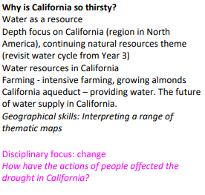  Oceans  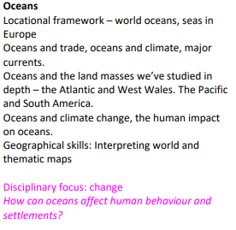 | Settlements (Stone Age, Romans and Anglo-Saxons)  Local area study  Map Skills  The Americas (Y5/6)  Around the World (Y3/4)
Design and Technology | Master practical skills  Design, make, evaluate and improve  Take inspiration from design throughout history | Bridges  - Participate in discussions and offer ideas.  - Evaluate images using simple responses, sometimes using formal elements to extend ideas.  - Provide plausible suggestions for how a piece was created.  - Comfortably use different stimuli to draw from.  - Use past knowledge and experience to explore a range of drawing processes.  - Select and place textures to create a collagraph plate, applying an understanding of the material, which may be supported by testing.  - Create a selection of drawings and visual notes that demonstrate their ideas using sketchbooks.  - Generate a clear composition idea for a final piece that shows how it will be drawn.  - Apply confident skills to make an effective collagraph print.  - Independently select tools and drawing techniques, with some guidance.  - Demonstrate growing independence, discussing ways to improve work. | Master practical skills (Y1,2,3,4, 5)  Design, make, evaluate and improve (Y1,2,3,4, 5)  Take inspiration from design throughout history (Y1,2,3,4, 5)
Art and Design | Develop ideas  Master techniques  Take inspiration from the greats | I need space  - Understand and explain what retrofuturism is.  - Participate in discussions and offer ideas.  - Evaluate images using simple responses, sometimes using formal elements to extend ideas.  - Provide plausible suggestions for how a piece was created.  - Comfortably use different stimuli to draw from.  - Use past knowledge and experience to explore a range of drawing processes.  - Select and place textures to create a collagraph plate, applying an understanding of the material, which may be supported by testing.  - Create a selection of drawings and visual notes that demonstrate their ideas using sketchbooks.  - Generate a clear composition idea for a final piece that shows how it will be drawn.  - Apply confident skills to make an effective collagraph print.  - Independently select tools and drawing techniques, with some guidance.  - Demonstrate growing independence, discussing ways to improve work. | Describe the work of notable artists,  artisans and designers (EYFS, Y1, Y2, Y3, Y4, Y5)
Religious Education | Understand beliefs and teachings  Understand practices and lifestyles  Understand how beliefs are conveyed  Reflect  Understand values | Stories of Prophets  Stories from the Qur’an and Muslim tradition, including:  Stories of the prophets: Adam, Nuh, Ibrahim, Musa, Suleyman, Dawud The Valley of the Ants  What Muslims learn from these stories, both in the past and today.  Where these stories can be found and how they have been passed on Continuities and contrasts in stories within different faiths in the Abrahamic tradition  Disciplinary focus: What do Muslim peoples learn from their stories?  Unit 2 – Awaiting Opening Worlds Resources | Understand beliefs and teachings (Y1,2,3,4, 5)  Understand practices and lifestyles (Y1,2,3,4, 5)  Understand how beliefs are conveyed (Y1,2,3,4, 5)  Reflect (Y1,2,3,4, 5)  Understand values(Y1,2,3,4, 5)
Languages | Read fluently  Write imaginatively  Speak confidently | Phonics 3&4 (C)  - Spanish Phonemes/ alphabet: GA GE GI GO GU QU Z, B, V, CC  The Date (I)  - Spanish phonemes/ alphabet GA GE GI GO GU QU Z,  - Remember, recall and spell the seven days of the week. Remember, recall and spell the twelve months of the year. Remember, recall and spell numbers 1-31.  - Use their knowledge of the days of the week, months of the year and numbers 1-31 in order to say the date.  - Use their knowledge of the months of the year, numbers 1-31 in order to say when their birthday is.  My Home (I)  - Spanish phonemes/ alphabet GA GE GI GO GU QU Z,  - Say whether they live in a house or an apartment and say where it is. Repeat, recognise and attempt to spell up to ten nouns (including the correct article for each) for the rooms of the house in Spanish. Tell somebody in Spanish what rooms they have or do not have in their home.  - Ask somebody else in Spanish what rooms they have or do not have in their home.  - Attempt to create a longer spoken or written passage in Spanish recycling previously learnt language (incorporating personal details such as their name and age) | Spanish Phonics (Y3/4/5)  Presenting myself (Y3/4/5)
Physical Education | Develop practical skills in order to participate, compete and lead a healthy lifestyle | Hockey  Netball  Gymnastics | Gymnastics (Y3/4)  Net and Wall (Y3/4)  Invasion Games (Y3/4)
Computing | Code  Collect  Communicate  Connect | Y6 - Online safety  - Discuss a range of issues online that can leave pupils feeling sad, frightened, worried or uncomfortable and can describe numerous ways to get help.  - Explain how sharing online can have both positive and negative impacts.  - Be aware of how to seek consent from others before sharing material online and can describe how content can still be shared online even if it is set to private.  - Explain what a ‘digital reputation’ is and what it can consist of.  - Understand the importance of capturing evidence of online bullying and can demonstrate some of these methods on the devices used at school.  - Describe ways to manage passwords and strategies to add extra security such as two-factor authentication.  - Explain what to do if passwords are shared, lost, or stolen.  - Describe strategies to identify scams.  - Explain ways to increase their privacy settings and understand why it is important to keep their software updated.  Computing systems and networks: Search engines  - Explain what a search engine is, suggesting several search engines to use and explain how to use them to find websites and information.  - Suggest that things online aren’t always true and recognise what to check for.  - Explain why keywords are important and what TASK stands for, using these strategies to search effectively.  - Recognise the terms ‘copyright’ and ‘fair use’ and combine text and images in a poster.  - Make parallels between book searching and internet searching, explaining the role of web crawlers and recognising that results are rated to decide rank. | Code (Y1,2,3,4, 5)  Collect (Y1,2,3,4, 5)  Communicate (Y1,2,3,4, 5)  Connect (Y1,2,3,4, 5)
Maths | Know and Use Numbers  Add and subtract  Multiply and divide  Use fractions | - Place Value  - Addition and subtraction  - Fractions | Know and Use Numbers (Y3/4/5)  Add and subtract (Y3/4/5)  Multiply and divide (Y3/4/5)  Use fractions (Y3/4/5)
English | Understand texts  Transcribe  Compose  Analyse  Present | Fiction: Narrative – Cosmic  Fiction: Narrative Horror - A Monster Calls  Poetry - Malfaesance  Non-fiction - Persuasive Letter – Scrooge | Understand texts (Y1,2,3,4)  Transcribe (Y1,2,3,4)  Compose (Y1,2,3,4)  Analyse (Y1,2,3,4)  Present (Y1,2,3,4)
PSHE | Mental wellbeing  Being a Good Citizen | Be Yourself  This unit is inspired by the idea that we are all individuals and that  it is important to ‘be yourself’. It aims to encourage the children  to develop a positive view of themselves and enable them to  recognise the importance of being proud of their individuality.  In this unit, children focus on the importance of recognising  situations where they need to make positive choices in order  to do the right thing. They also explore how to avoid being led  into tricky situations and how to recognise and respond to peer  pressure. The unit will also look at how to be confident and how  to manage uncomfortable feelings. The unit ends by helping the  children to investigate how to make things right when they make  a mistake.  Britain  This unit is inspired by the idea that Britain represents a wide range of faiths and ethnicities and that the structures within it are there to support all. It aims to enable the children to identify how they can make a positive contribution to the community. In this unit, children learn about the law and the consequences of not respecting it. They will also learn about the workings of local and national government and the role of charities and voluntary groups in British society. | Mental wellbeing(Y1,2,3,4,5)  Being a Good Citizen (Y1,2,3,4,5)
Music | Perform  Compose  Transcribe  Describe music | Composition notation (Theme: Ancient Egypt)  Based on the theme of Ancient Egypt, children learn to identify the pitch and rhythm of written notes and experiment with notating their compositions, developing their understanding of staff notation.  Film music  Exploring and identifying the characteristics of film music. Creating a composition and graphic score to perform alongside a film. | Year ¾ - Ancient Egypt

